YOGASANAS - IN PRONE POSITION

BHUJANGASANA (Saralhasta)
Cobra pose

Introduction :
This posture is called bhujangasana (cobra pose) because the spine resembles a cobra when it raises its hood. Raising the chest up may be difficult in the initial stages of practice. One can begin using the arms as support. In advanced stages of the pose, the hands are not used for support. Instead, the back muscles are engaged to lift the torso off the floor. However, in this variation of bhujangasana, both the arms should remain straight, hence referred to as ‘straight armed bhujangasana.’
Taking The Position :
Initial Position : Prone Position.
1) Bring both the hands near the chest and place the palms down, facing forward. Keep the fingers together and point the thumbs towards the body. The elbows of both arms should point towards the sky. Rest the forehead on the ground and exhale.
2) While inhaling, raise the forehead and chin. Gradually raise the shoulders and chest and straighten the arms.
Focus the gaze behind, bending the neck back as much as possible.
Asana Position:
Initially, one feels the whole weight of the body on the hands; however, after some practice, lifting solely by engaging the muscles of the lower back becomes possible. Once the final position is attained, one should keep the arms straight while pressing the waist down and opening the chest. Maintain an arched spine and breathe normally.
Releasing The position :
1) Inhale, and while exhaling, with the support of the back muscles, slowly lower the shoulders. Lower the stomach, then the chest, and take position No. 1 mentioned above.
2) Place the chin on the floor, take the hands back towards the waist, and keep them straight. Take the prone position.
Duration :
After taking the final position, maintain it for 5 to 10 seconds and repeat three to five times. With practice, the number of repetitions will increase and one will be able to do five repetitions with ease. Later, one may start reducing the number of repetitions, while increasing the duration of each asana up to 1 minute. This duration can be gradually increased up to 3 to 5 minutes.
Internal Effects :
This asana primarily affects the spinal cord and the stomach muscles. Forward bends of the back-bone are common in daily routines, but backward bends throughout the day are rare. Therefore, it is important to practice backward bends to balance out the forward bends. Also, the compression of the abdomen benefits the digestive organs. This asana strengthens the backbone, adding flexibility, thereby preventing and removing back troubles. Displacement may also be cured by this asana. Engaging the back muscles leads to enhanced blood circulation throughout the lower half of the body and the spinal column. It also helps to cure flatulence.
Precaution:
People suffering from diseases of the spinal column, Tuberculosis, stomach ulcers, or hernia, are recommended to practice this asana under the supervision of a qualified yoga expert. Practice gently if the spine is very stiff, and take care to avoid abrupt, jerk-like movements.
BHUJANGASANA (Vakrahasta)
Cobra pose with bent arms
Introduction-
This is an advanced stage of bhujangasana. This asana is difficult, but more beneficial than bhujangasana with straight arms. This asana should be practiced only after acquiring mastery in bhujangasana with straight arms.
Taking The Position :
Initial Position: Prone Position
1) Bring both the hands near the chest, placing the palms on the floor with the fingers together, pointing forward with the thumbs drawn towards the body. The elbows of both arms should be kept raised towards the sky. Now touch the forehead to the ground, and exhale.
2) While inhaling, gradually raise the forehead, then the chin, chest and neck. Curve the spinal column, keeping the waist, thighs and
knees pressed to the floor. Raise the upper body up to the navel. In this position, the palms are firmly pressed against the floor and the elbows are bent. After taking the final position, continue to breathe normally.

Asana Position :
Although in the final position, both the hands are used for support, it is better not to apply much pressure on them. One should be able to maintain the asana without the hands. The spinal column should be curved as much as possible and the neck curled backward. Continue to breathe normally.
Releasing The Position :
1) Inhale, and while exhaling, gradually bring the abdomen, chest, shoulders, and neck down on the floor. Keep the forehead resting on the ground and take position No.1, as discussed above.
2) Placing the chin on the ground, take both hands back as in the starting position, and come to the prone position.
Duration :
Like bhujangasana saralhasta, the duration of the asana should increase with the progress of practice.
Precautions & The Internal Effects :
The same as mentioned for bhujangasana saralhasta.
SHALABHASANA
Locust pose
Introduction :
"Shalbha” means "Locust”. The position of the body in this asana resembles a locust and is therefore given the name "shalabhasana.” In this asana both the legs are raised while resting chin down in the prone position. Although not mentioned in the yoga classics, ardha shalabhasana (with one leg raised at a time), is also worth learning as it facilitates the study of full shalabhasana.

ARDHA SHALABHASANA (LEFT SIDE)
Half locust pose
Taking The Position :
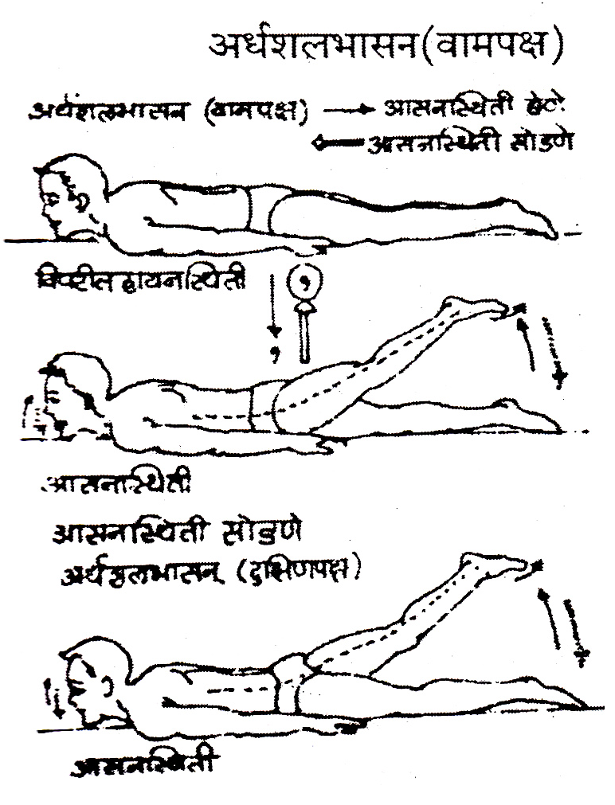
Initial Position: Prone Position
1) Exhale, and while inhaling, raise the left leg from the waist, keeping it straight. Keep the toes pointed back and continue to breathe normally.
Asana Position :
In this asana, the leg should be raised and kept stable, without
bending in the knee. A straight knee helps pull on the organs to achieve the maximum benefit from this pose. The posture should be maintained with the chin resting on the ground. The shoulders, neck, and head are relaxed, while the muscles of the thighs and abdomen should be kept engaged and lengthened. The opposite leg should be kept straight and pressed into the floor. Initially, one can use the hands to support and to aid in raising the leg. However, with practice, one should successfully raise the leg without use of the hands.
Releasing The Asana Position:
1) Inhale, and while exhaling, slowly lower the left leg down on the ground, returning to prone position.

ARDHA SHALABHASANA (Right side)
The above mentioned process is to be followed while raising the right leg.
Duration :
Initially, one can maintain the position for less time, using more repetitions. Six repetitions should be held for 5 seconds for a total of 30 seconds. With more practice, one may maintain the asana for up to one minute.
SHALABHASANA (Full)

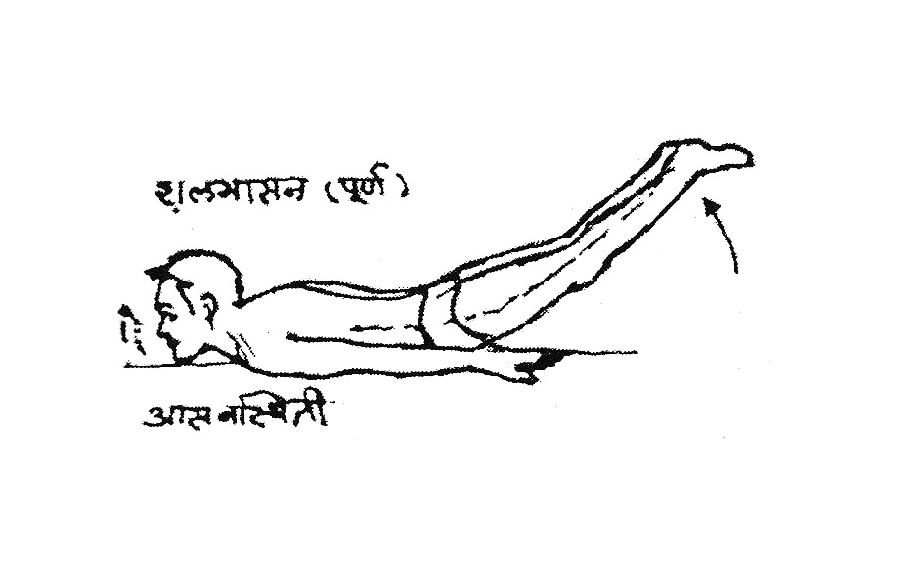

The process of entering & releasing this asana is the same as in ardha shalabhasana. However, in ardha shalabhasana, only one leg is raised at a time, whereas in shalabhasana, both the legs are raised and lowered together, simultaneously.
Asana Position :
With the legs extended and the toes pointing back, use the muscles of the lower back to raise the legs up. Raise the legs as much as possible and then retain the position. Breathe normally. If trembling occurs, lower the legs slightly until it stops. Then maintain the position. Relax all the muscles of the body except those of the thighs and stomach.
Duration:
Since this asana can be quite challenging in the initial stages of practice, it is recommended to start with shorter duration and more repetitions to build endurance. Begin holding for 15 seconds and repeat three to five times.
Internal Effects:
In shalabasana, the exertion is focused mainly on the lower back, the muscles of the abdomen, and the thighs, increasing blood circulation to these areas. This asana stimulates the functioning of various internal organs, particularly, the small and large intestines, and certain enzyme producing glands.
Precaution:
The same as stated for bhujangasana.

DHANURASANA
Bow Pose
Introduction:
In this asana, the body takes the shape of a bow (dhanu), and is therefore called dhanurasana. Like a bow with the string is drawn back, performing this asana creates an arc, elongating the front of the body, while contracting the back half.
Taking The Asana Position :

Initial Position : Prone Position

1) Bend both the legs at the knees, keeping them 6 to 8 inches from each other.
2) Grab the left ankle with the left hand and the right with the right hand.
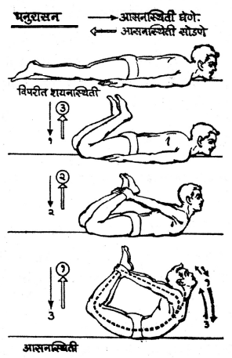
3) Exhale, & while inhaling, firmly hold the ankles, pulling the legs up and forward, forming an arc with the body. Extend up and back through the neck and maintain this position while breathing normally.
Asana Position:
Once the final position has been achieved, try raising the thighs, shoulders, and chest up off the floor simultaneously, as much as possible. In this position, the weight of the body rests on the abdomen. Stretching the arms back, while holding the bent legs, opens the chest and shoulders. The neck extends up and back, completing the round arc. In the initial stages of practicing this asana, some distance between the two knees is permissible. However, after some practice, aim to narrow the space, eventually keeping the knees pressed together.
Releasing The Asana Position :
1) Inhale, and while exhaling, bring the knees, shoulders and chin slowly to the floor.
2) Release the ankles and bring the hands to the sides.
3) Straighten the legs and bring them to the floor, returning to prone position.
Duration :
Initially, try to maintain the posture for five seconds. With practice, the time should be increased to ten seconds, and practiced three times. One can work to increase the time up to three minutes. Benefits can still be attained by maintaining the position for thirty seconds.
Internal Effects :
Dhanurasana is a mixture of both bhujangasana & shalabhasana, therefore it provides similar benefits. In this posture, the stretch is felt in the back, thighs, shoulders, arms and in particular, the abdomen. The pressure exerted on the abdomen stimulates the internal organs and enzyme producing glands, such as the liver and pancreas, thus improving the digestive system and enhancing peripheral circulation.
Precaution :-
The same as mentioned for bhujangasana. Those with abdominal trouble should not do this asana without guidance from a qualified yoga expert.

NOUKASANA

Boat pose
Introduction :
The shape of the body in this Asana resembles a boat, hence it is called ‘noukasana” (“Nouk,” Sanskrit for “boat”).
Taking The Asana Position :
Initial Position : Prone Position

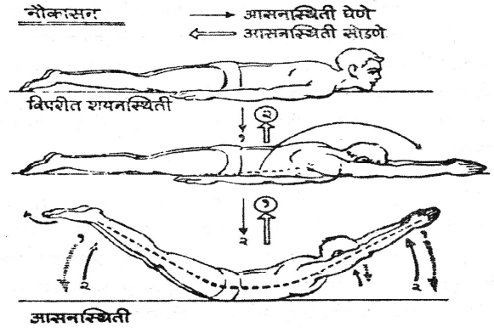
1) Reach both arms forward over the head, keeping them straight. Join the palms and place the forehead on the floor. 2) Exhale, and while inhaling, raise the neck, arms, legs and back off the floor. Raise up as much as possible, point the toes, and stretch the legs back, while lengthening the hands and head towards to front. Breathe normally.
Asana Position :
In noukasana, the legs and torso raise off the floor while the head is kept in line with the outstretched arms. The shoulders and the legs should be elevated as much as possible, the abdomen supporting the weight of the body. Initially it may be challenging, but after adequate practice it becomes possible to raise the legs at the level of 45 degrees.

Releasing The Position :
1) Inhale, and while exhaling, lower the arms and legs, resting the forehead on the floor.
2.) Take the arms back to the sides of the body, palms facing down, placing the chin on the floor.

Duration:
Noukasana is harder to maintain for extended time, than dhanurasana. As with the other asanas, regular practice will help to increase the length of hold. One should aim, but not exceed, to hold for 2 minutes.
Internal Effects :
In noukasana there is more tension in the arms and legs than in dhanurasana. The pressure exerted on the abdomen compresses the internal organs and improves their function. This asana also activates the muscles of the back and helps to get rid of digestive complications.
Precaution:
The same as bhujangasana. Due to the pressure on the abdomen, one should release the posture if it becomes uncomfortable. The posture should be avoided in cases of hernia, pregnancy, menstruation, abdominal surgeries etc..

MAKARASANA
Crocodile Pose
Introduction :
Makarasana can be used as a resting pose while practicing asanas in prone position. "Makara” means crocodile. In this asana the body takes a similar posture to a crocodile lying in the sand.

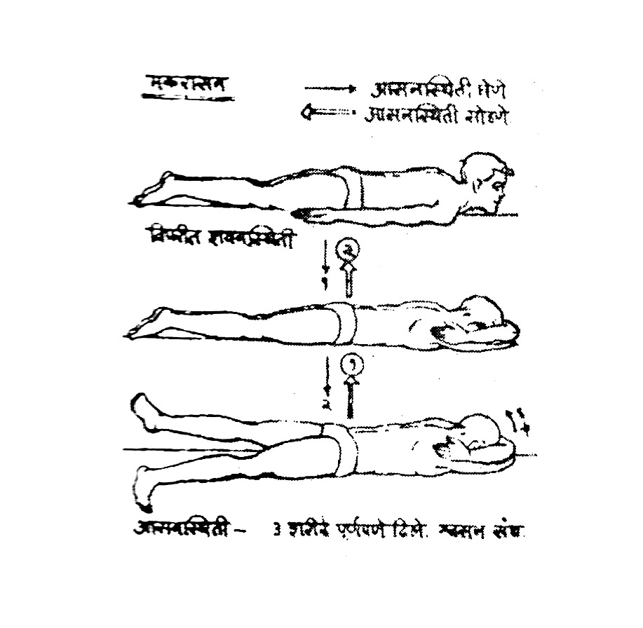

Taking The Asana Position :
Initial Position : Prone Position
1) Fold the arms around the head, place the forehead on the forearms and relax the neck.
2) Spread the legs and keep them a foot’s distance apart, facing the toes outwards while allowing the heels to fall inward.
3) Relax and rest the whole body on the floor. Breathe normally, keeping the head in a comfortable position.
Asana Position :
Makarasana is a relaxation pose and is not meant to produce any strain on the body. As the breath slows, the focus is on relieving tension and taking time to rest. The aim of this asana is to release the strain caused by the practice of other asanas. In order to maximize the benefits, this asana should be maintained for two to three minutes.

Releasing The Asana Position:
1) Bring the feet together, heels and toes touching.
2) Unfold the arms, and take them back, resting them at the sides, returning to Prone Position.
Internal Effects:
In this asana, the body is relaxed and there is a decrease in the muscles’ demand of blood and oxygen supply. Consequently, the heart rate and breath slow down, allowing all bodily systems to rest.
Precaution :
This pose does not have any significant precautions but it is important that although the body is relaxed, one should avoid falling asleep.
* * *

